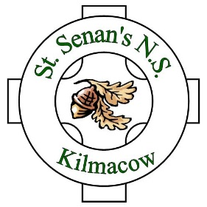
St. Senan’s N.S.
ANNUAL ADMISSION NOTICE
in respect of admissions to the 2024/2025 school year

Admission Policy and Application Form
A copy of the school’s Admission Policy and the Application Form for Admission for the 2024/25 school year is available as follows:–
To download at: www.stsenansns.ie
On request: By emailing info@stsenansns.ie or writing to: The Secretary, St. Senan’s N.S., Kilmacow, Co. Kilkenny

PART 1 - Admissions to the 2024 – 2025 school year

Application and Decision Dates for admission to 2024 - 2025
The following are the dates applicable for admission to Junior Infants:

The school will commence accepting applications for admission on | 27th November 2023
The school shall cease accepting applications for admission on | 19th January 2024
The date by which applicants will be notified of the decision on their application is | 2nd February 2024
The period within which applicants must confirm acceptance of an offer of admission is | 9th February 2024

Note: the school will consider and issue decisions on late applications in accordance with the school’s admission policy.

Number of places being made available in 2024 - 2025

The number of places being made available in Junior Infants is | 28

