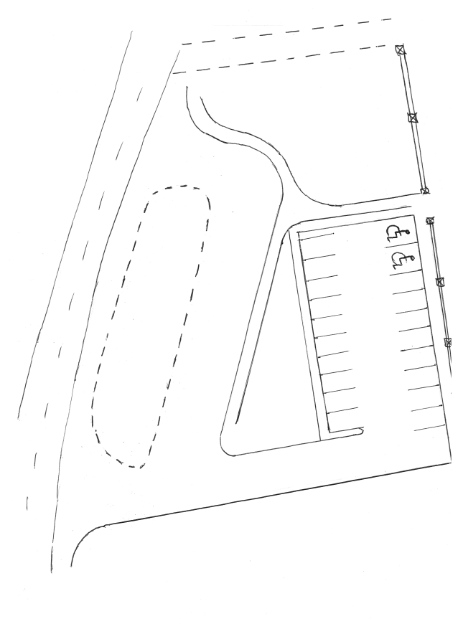
Parking Arrangements at the Junior Building from Monday 19th October
Please take some time to familiarise yourself with this new lay out. Detailed instructions are on the back of this sheet. Please pass on this message to other drivers who may be collecting your child.
YIELD!

