Mr. Mo-Snake

The mosaic in the shelter in our Senior Building was created in October 2011 by the pupils of what was St. Joseph’s Girls’ National School. This project was carried out under the guidance of Maedhbh Brosnan (The Mosaic Project Co.). Each girl designed her own section and glued on various tiles and “found objects”. The finished pieces were then grouted before being fixed to the wall.

Junior and Senior Infants created the 29 square tiles that act as a backdrop to the snake. Below is a “map” of those squares and a list of their creators.
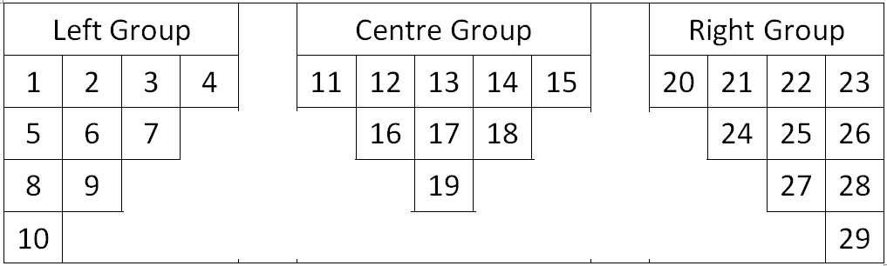

1) Haley Norris 2) Lily Green 3) Juliet Evans 4) Ms Duggan 5) Gabrielle Bergin-Brogan 6) Enya Ryan
7) Sallyann O’Brien 8) Anna O’Callaghan 9) Alicia Scully 10) Sophie Williams 11) Caoimhe Kavanagh
12) Anna Fenton 13) Caitlin Coady-Hamilton 14) Mia Buggy 15) Caoimhe Phelan 16) Libby Murphy
17) Shannon-Lee McKenna 18) Aoife Bradley-Moore 19) Alanna Tobin 20) Kate O’Mara 21) Áine Cooper
22) Maedhbh Brosnan 23) Auveen Moore 24) Ella Daly 25) Amelia Phelan 26) Abbie Hearne
27) Jessica Grant 28) Leah Daly 29) Gail Ferguson

The Snake consists of sections for the head and tail and 52 separate body segments. These segments were designed and created by the girls of First to Sixth Classes. Again, the girls brought in many “found objects” and these can be spotted on close inspection. The head and tail sections were a joint effort by the teachers, again under the guidance of Maedhbh.

Beginning from the head, heading towards the tail, the creatosr of the segments are as follows:-
- Saoirse Allen | - Casey Moore | - Lana O’Doherty | - Chelsea Quigley
- Áine Phelan | - Ellen Power | - Hannah Lacey | - Dáire Dowling
- Nicole Cooke | - Máire Brennan | - Alexandra Dinea | - Rebecca Finnegan
- Emily Kleijn | - Anne-Marie Maloney | - Megan Phelan | - Caoimhe McLoughlin
- Nell Murphy | - Alice Walsh | - Siobhán Moher | - Leah Molloy
- Luiza Tinka | - Caoimhe Connolly | - Kathleen Croke | - Emma Costello
- Nadine Rushe | - Sarah O’Brien | - Caoimhe Williams | - Sinéad Sheridan
- Hannah Morrissey | - Sinéad McEvoy | - Georgina Walsh | - Molly Murrat
- Isabel Evans | - Mary Doherty | - Ríona Kinsella | - Caitlin Fennelly
- Aoife Allen | - Michelle Finnegan | - Erin Ryan | - Kate Corcoran
- Eve Lacey | - Rebecca Norris | - Una Kinsella | - Lauren Croke
- Grace Blanchfield | - Ella Doherty | - Tara Ryan | - Sophie Delahunty
- Sophie Walsh | - Nikole Tinka | - Abbie Carew | - Afton Grace
- Caitlin Daly | - Ciara Corcoran | - Abbie Murphy | - Clíona Murphy
- Lynda Gahan

