



December 2017

Dear Parents / Guardians,

As the end of our first term approaches, it's a good opportunity to take stock of some of what has occurred in St. Senan's N.S. over the past 4 months.

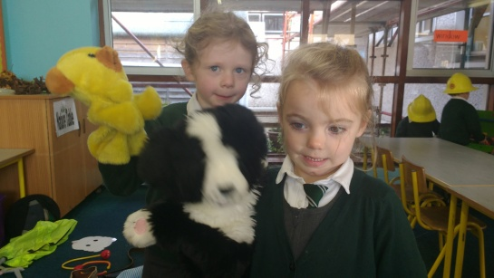We welcomed 14 Junior Infants to our school in September and the total enrolment of the school at the end of September was 171 children. As the school year commenced in September, the Junior Building was covered in scaffolding to facilitate the roof slates being replaced.

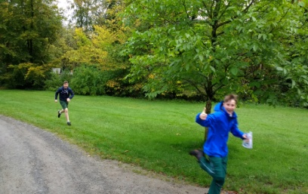The work continued on the Junior Building into October. After the new slates were installed, the outside of the building was painted. In the Senior Building the 5th and 6th class boys started their Gaelic football league. They played against South Kilkenny schools finishing with a great win against Mooncoin. Both 5th and 6th classes also went orienteering in Woodstock where they competed against other schools. The month ended with our annual Halloween party for the whole school in the Junior Building.

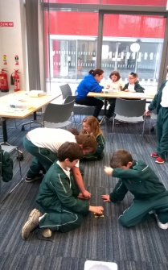

Over the mid term break the Junior Building was painted internally. In the Senior Building two of the classrooms had carpets installed and anti slip flooring was put into the cloakrooms. On the 13th of November a truck arrived from Team Hope to collect the 140 shoe-boxes collected by the children to share with less fortunate children in other countries. Children from 3rd class attended a Lego engineering workshop in Waterford. Ursula and Harry Knox visited the school from the local charity ‘Opportunity Knox’ to share their experiences helping children access education in Uganda.

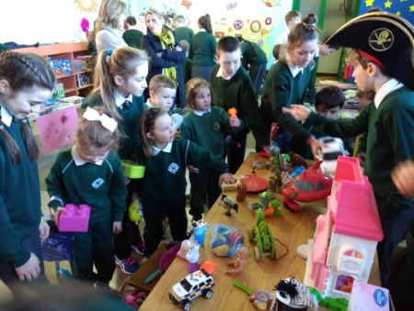

December started with a very successful 'Bring & Buy' organised by the 6th class children, it raised 460 euro for Opportunity Knox.  The school was successful in obtaining an additional classroom teacher for the remainder of the year resulting in the split Senior Infant class being brought back together for the remainder of the year. The festive season kicked off with a Carol Service in St. Senan's Church. Santa also took time off from his busy schedule to call into the school to visit the children and hear some carols.

I would like to express my thanks for your support over my first four months as principal and I look forward to continuing to work with you and your children in the New Year.

Nollaig shona dhaoibh

Kieran Walsh – Principal of St. Senan’s NS