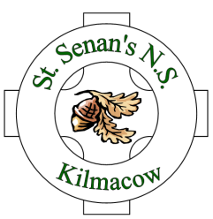

SCHOOL OPENING & CLOSING TIMES

Dear Parents/Guardians,

It has been noticed that, over the recent months, quite a few children are arriving to school quite early and this matter was discussed at our recent Board of Management meetings. Traditionally, children have always arrived early to our schools as they enjoy meeting up with their friends and classmates before school commences. However, with larger numbers arriving quite early in the mornings, the Board of Management felt that the current opening and closing times should be discussed.
Each family’s morning routine will be different with many and varied factors effecting each. The new opening times in the Abbey Community School, school bus times, childminders and parents/guardians working hours all playing their part in your morning schedule. In order to be more fully informed of your opinion on Opening Times the Board of Management requests you to complete the survey below and send it into the school before this Friday, 10th February. You are asked to indicate the opening time that is best suited to your circumstances. This is not a vote as the final decision on opening times is a matter for the Board of Management.

Signed,
On behalf of the Board of Management

M. Kavanagh
Principal, 06-01-2017

Please indicate with “X” the opening time that would best suit your morning routine.

Option A Opening at 9.20am and Closing at 3.00pm

Option B Opening at 9.00am and Closing at 2.40pm

